**Database Connectivity (Team-06)**

**Provide the code for database connectivity for each module in the project.**

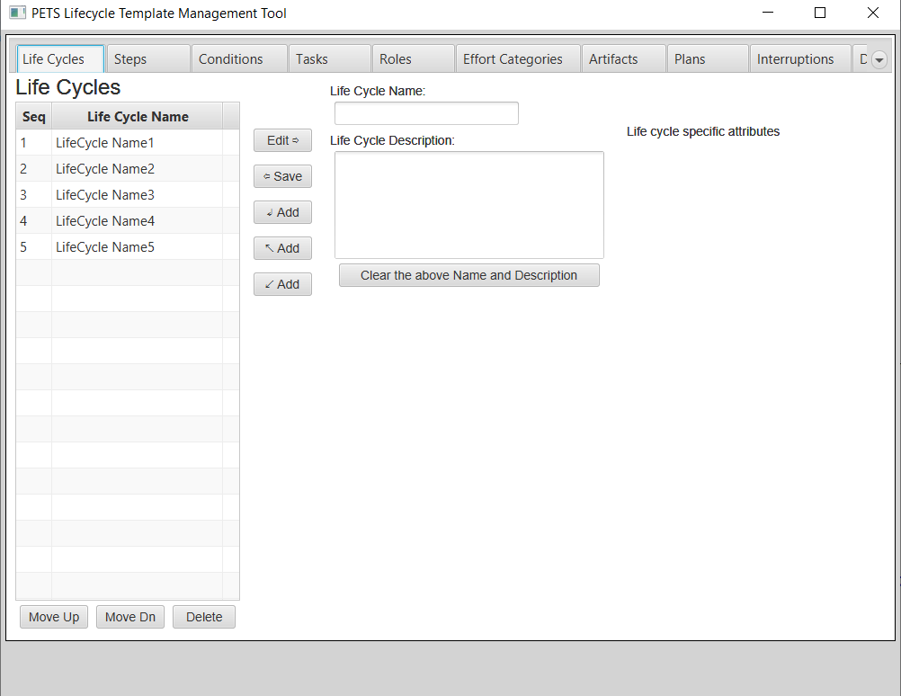

1. **Establishing the jbdc connection and retrieve data in table view.**

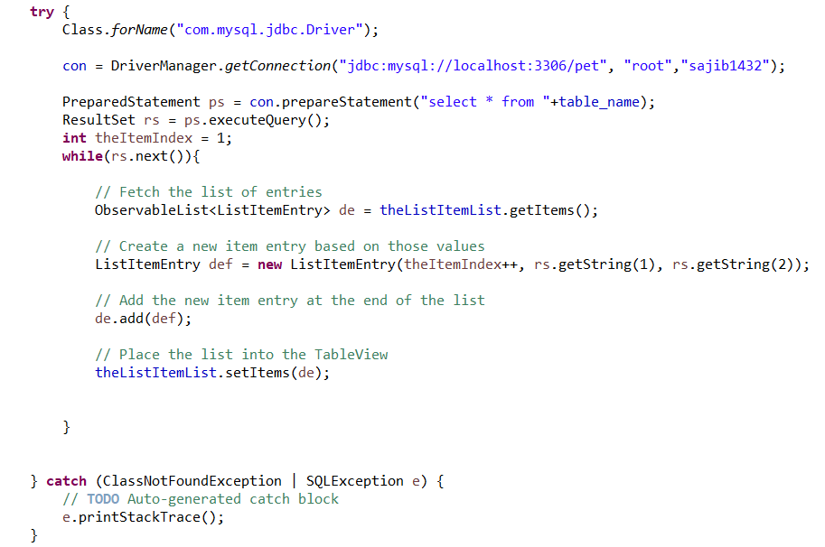

1. **Code to insert data in a table.**

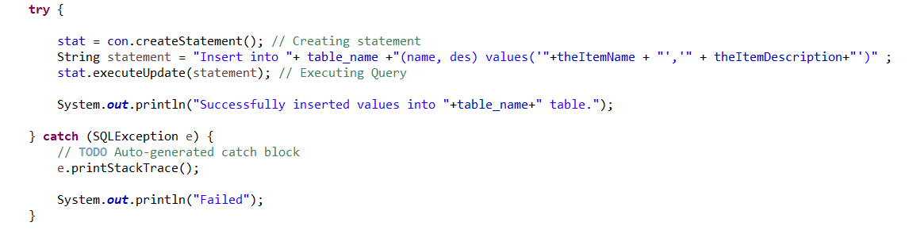

1. **Code to update data into table**

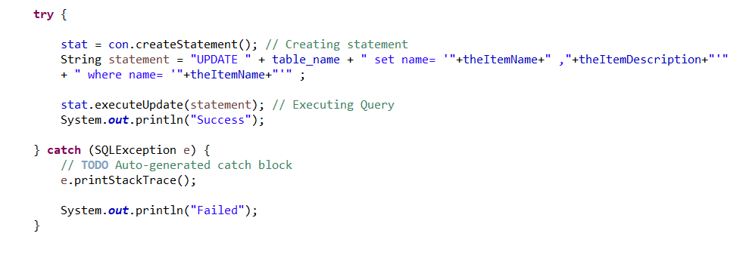

1. **Delete data from the table**

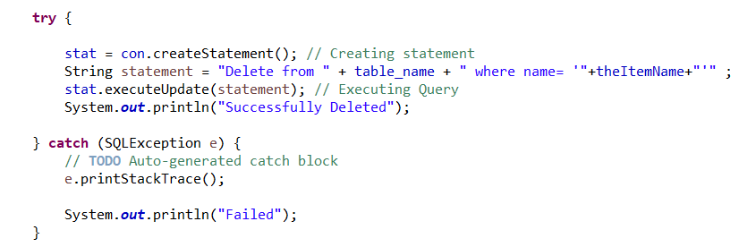

**Populate each table**

